**Vectors- Basics Idea**

**Vector Quantities:**

How to solve:

* Sketch the situation and use trigonometry to determine the final location relative to the initial position
* Make an accurate scale drawing to determine the final location relative to the initial position

e.g.

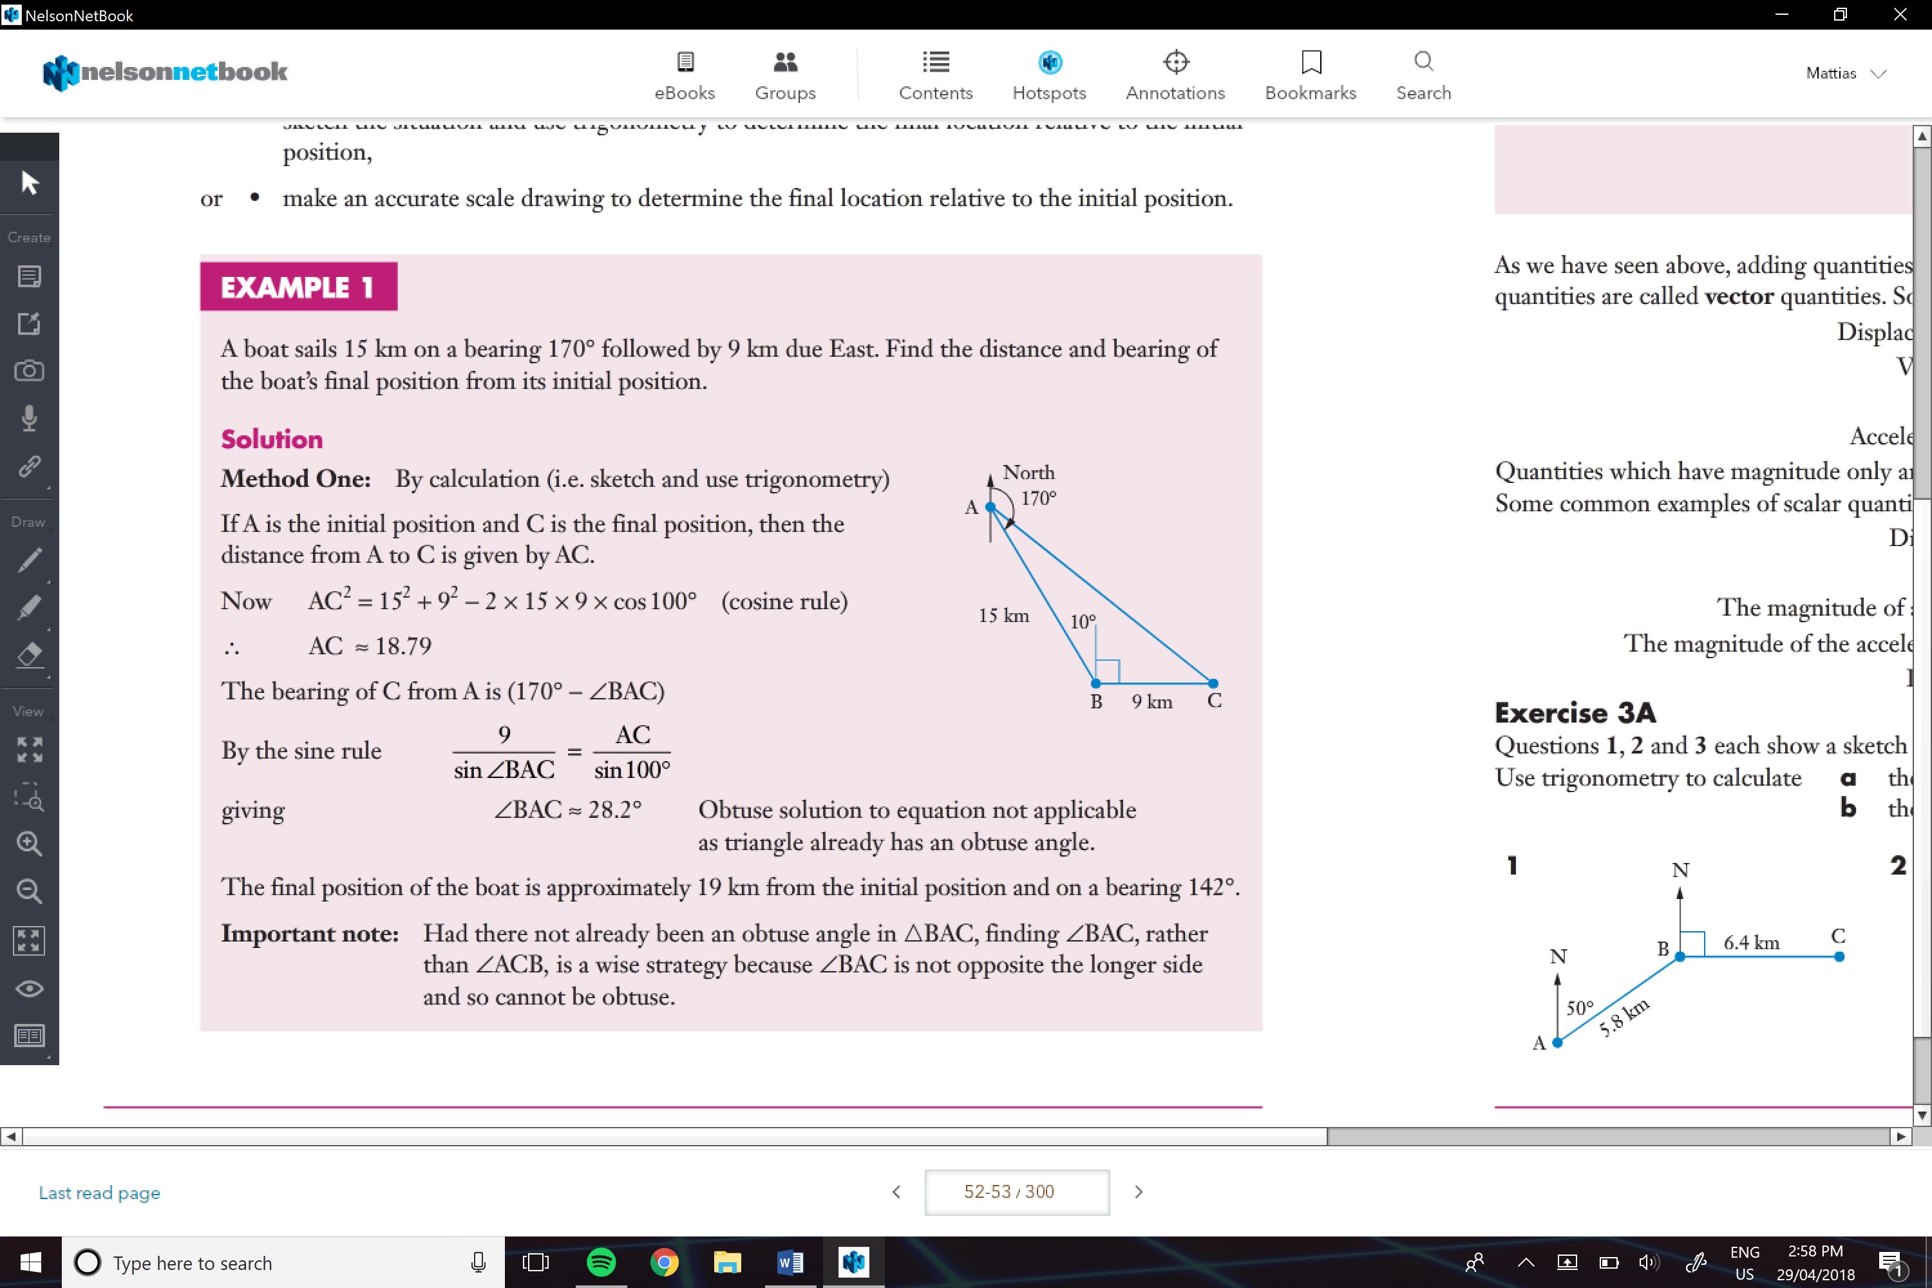

Vectors:

Are quantities that have magnitude and direction

e.g. Displacement, velocity, force, acceleration

Scalar:

Quantities that only have magnitude

e.g. distance, speed, magnitude of a force, magnitude of acceleration, energy

**Adding Vectors:**

We need to draw the lines/ vectors with nose to tail

And then using trigonometry we are able to find the resultant and the direction

e.g.

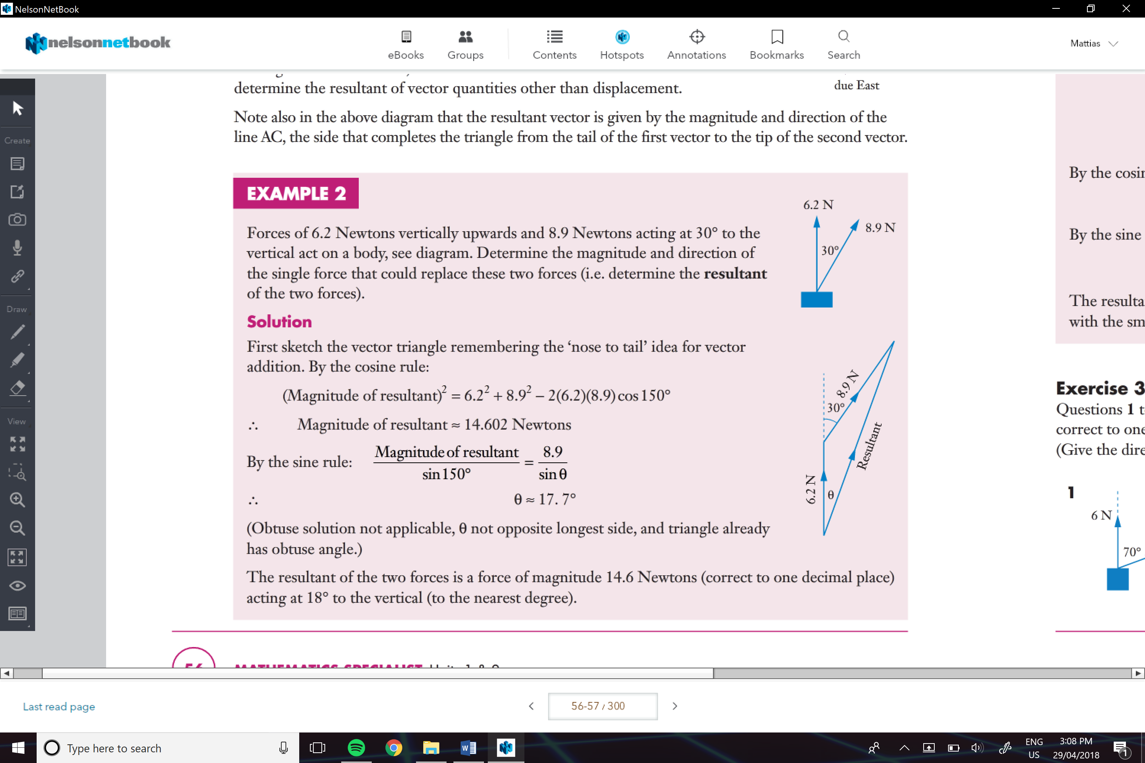

**Things I Stuggled with , go over again**(3C)

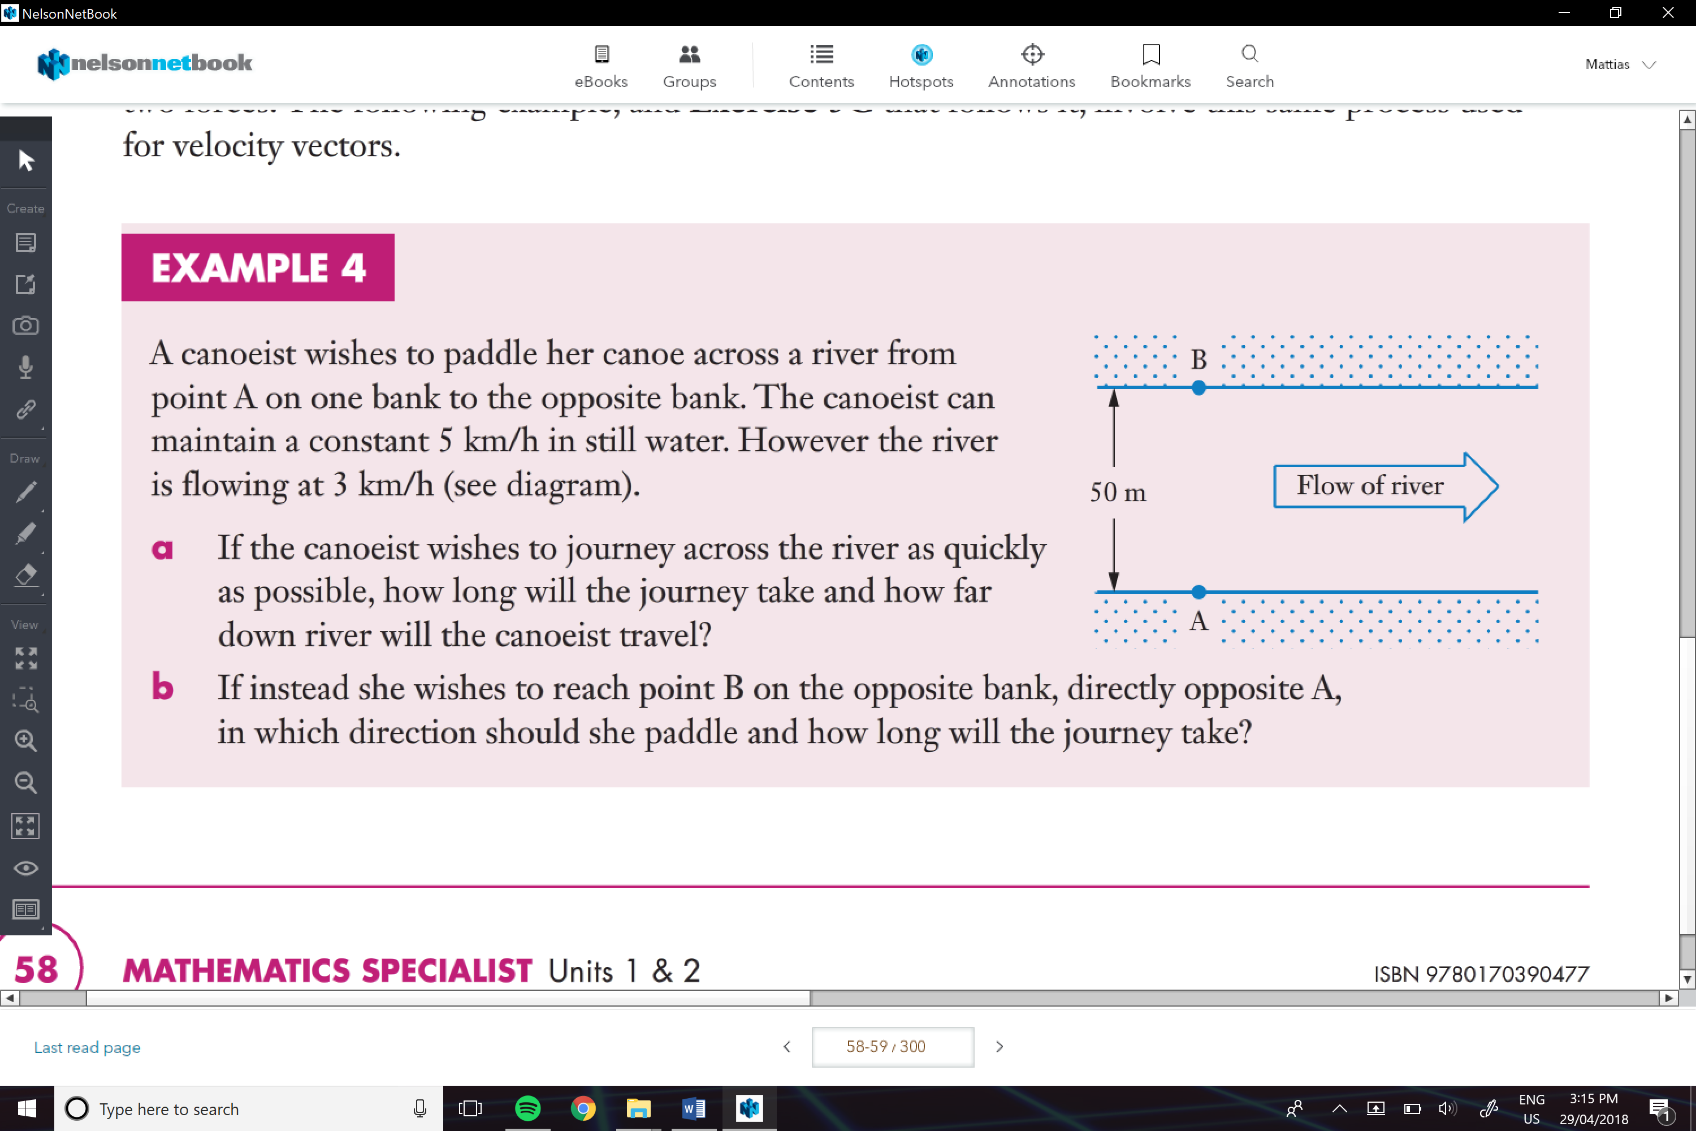

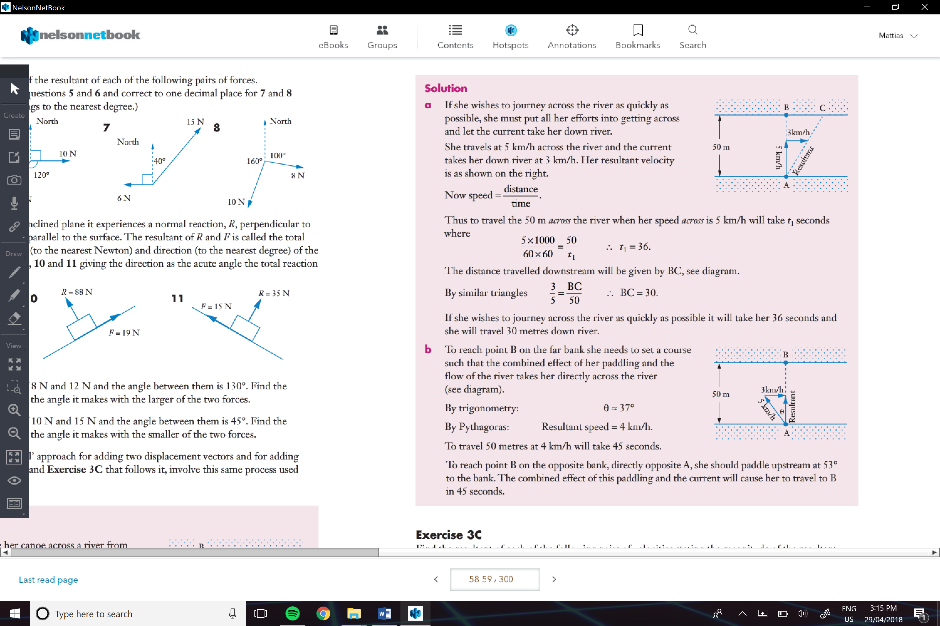

Representing Vectors:

-If we are talking a line from one point (A) to another (B), we represent it by placing a=n arrow on top of both letters.

- If the sides are already lettered, we bold them by underlining them, e.g. vectors a = a

- and for magnitude we write it with | |, e.g. |a|

Equal Vectors:

Two vectors that have the **same magnitude** and the **same direction**

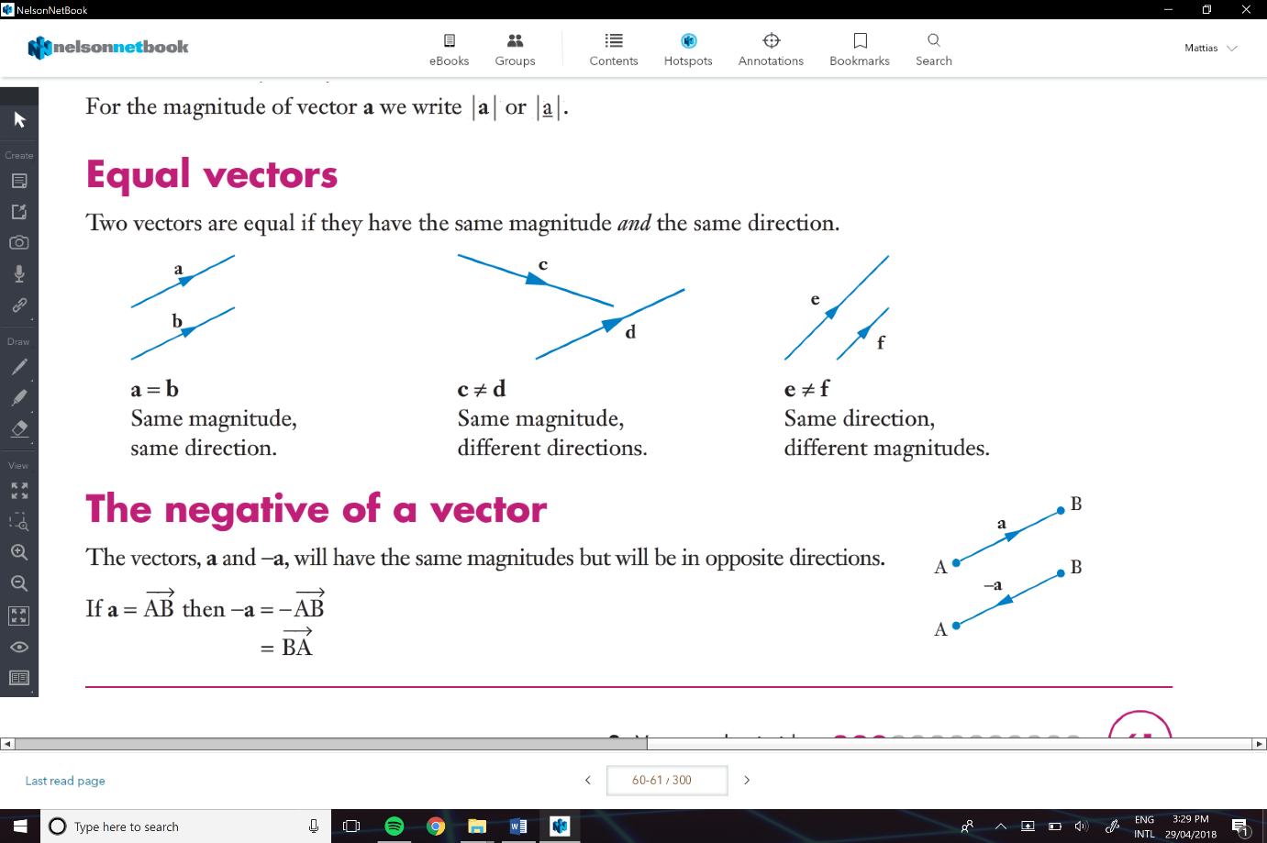

The negative of a vector:

Same magnitude but opposite direction

* If a = ->AB, then -a = - ->AB = ->BA

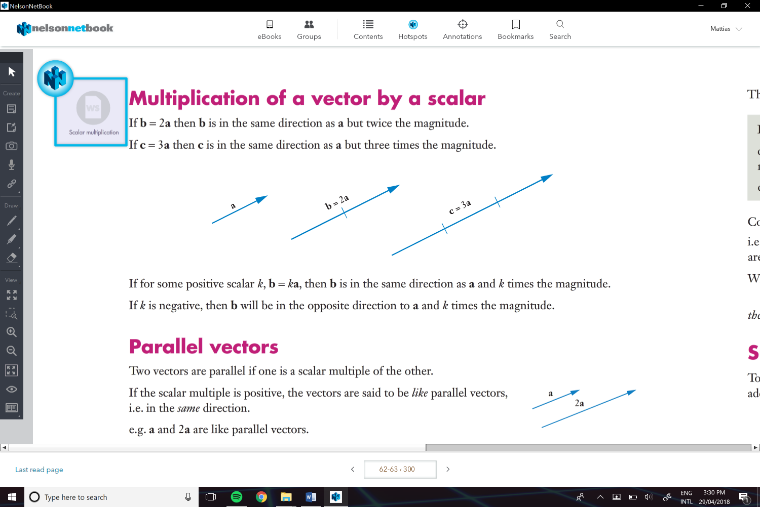Multiplication of a vector by a scalar:

If b=2a then b is the same direction as a but twice the magnitude

Parallel Vectors:

Two vectors that are parallel if one scalar multiple of the other

* If the scalar multiple is positive, the vectors are said to be *like parallel vectors*
* If the scalar multiple is negative, the vectors are said to be *unlike parallel vectors*

Addition of vectors:

* Is to add two vectors
* And also find the single/ resultant vectors (that replaces the two)

We do this by using a vector triangle

* Which the vectors are added from “nose to tail”, which forms two sides of the triangle.

e.g.

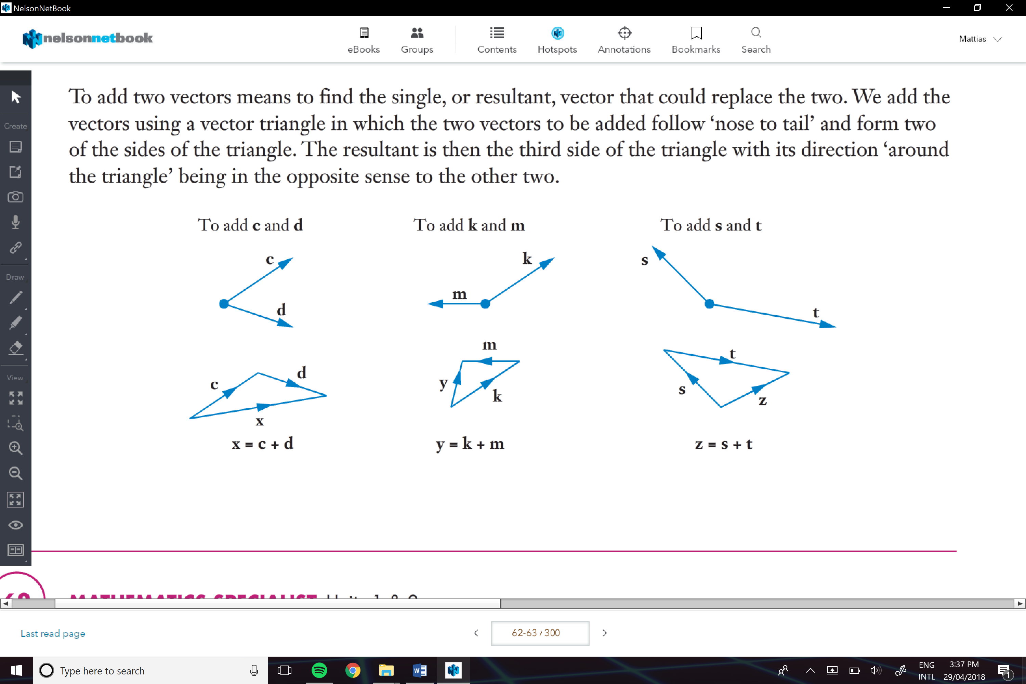

Subtraction of one Vector from Another:

Instead of a – b, instead be a + (-b)

With the parallelogram approach one diagonal is a+b and the other is a-b

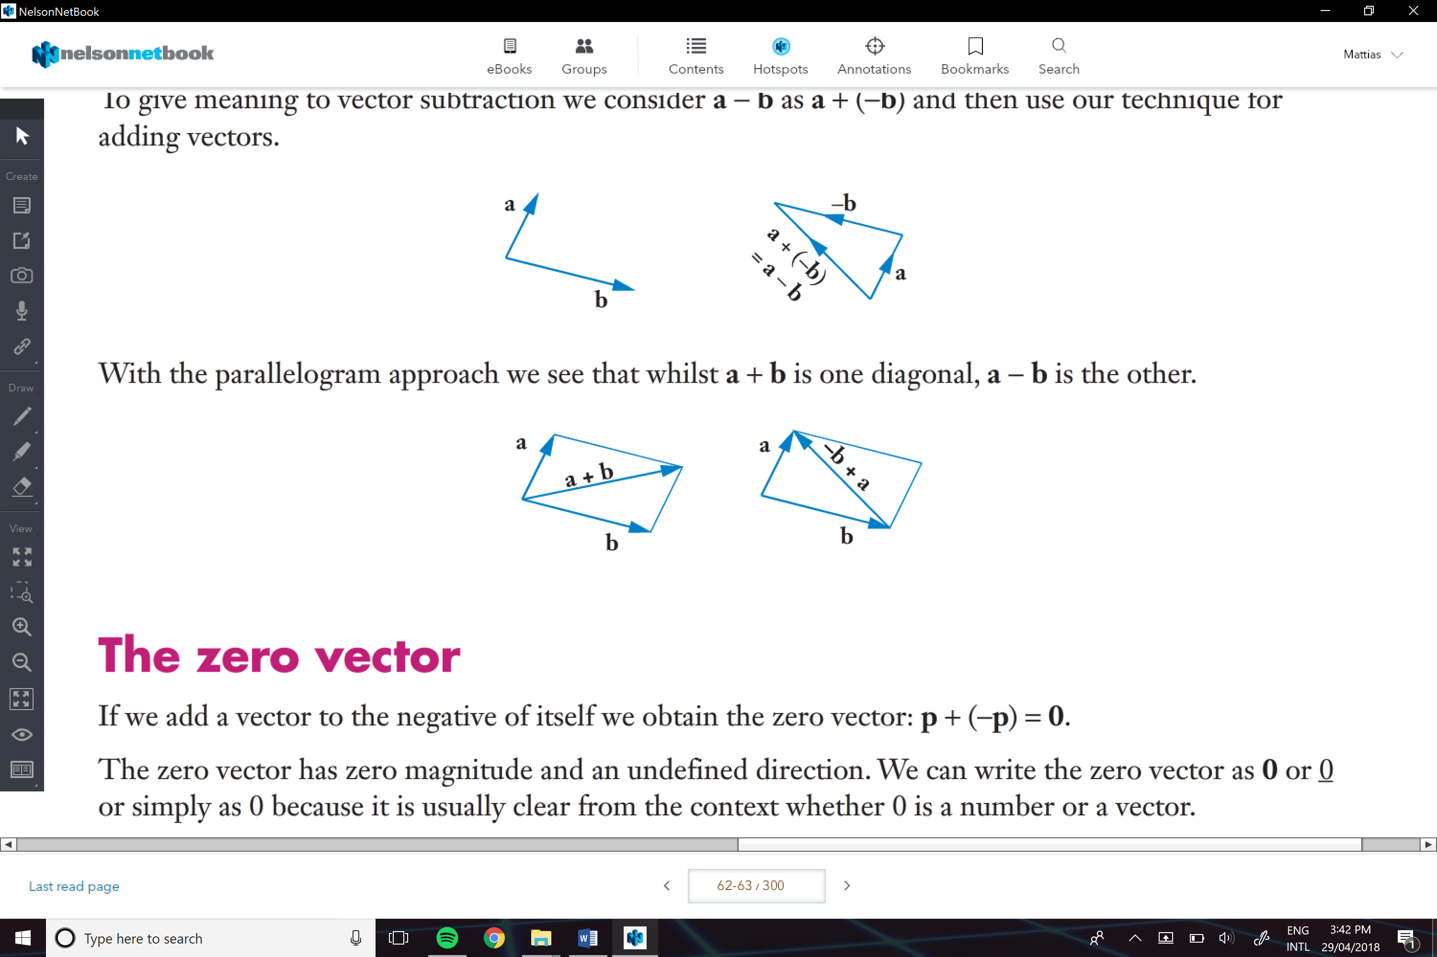

Also, the *triangle inequality* is…

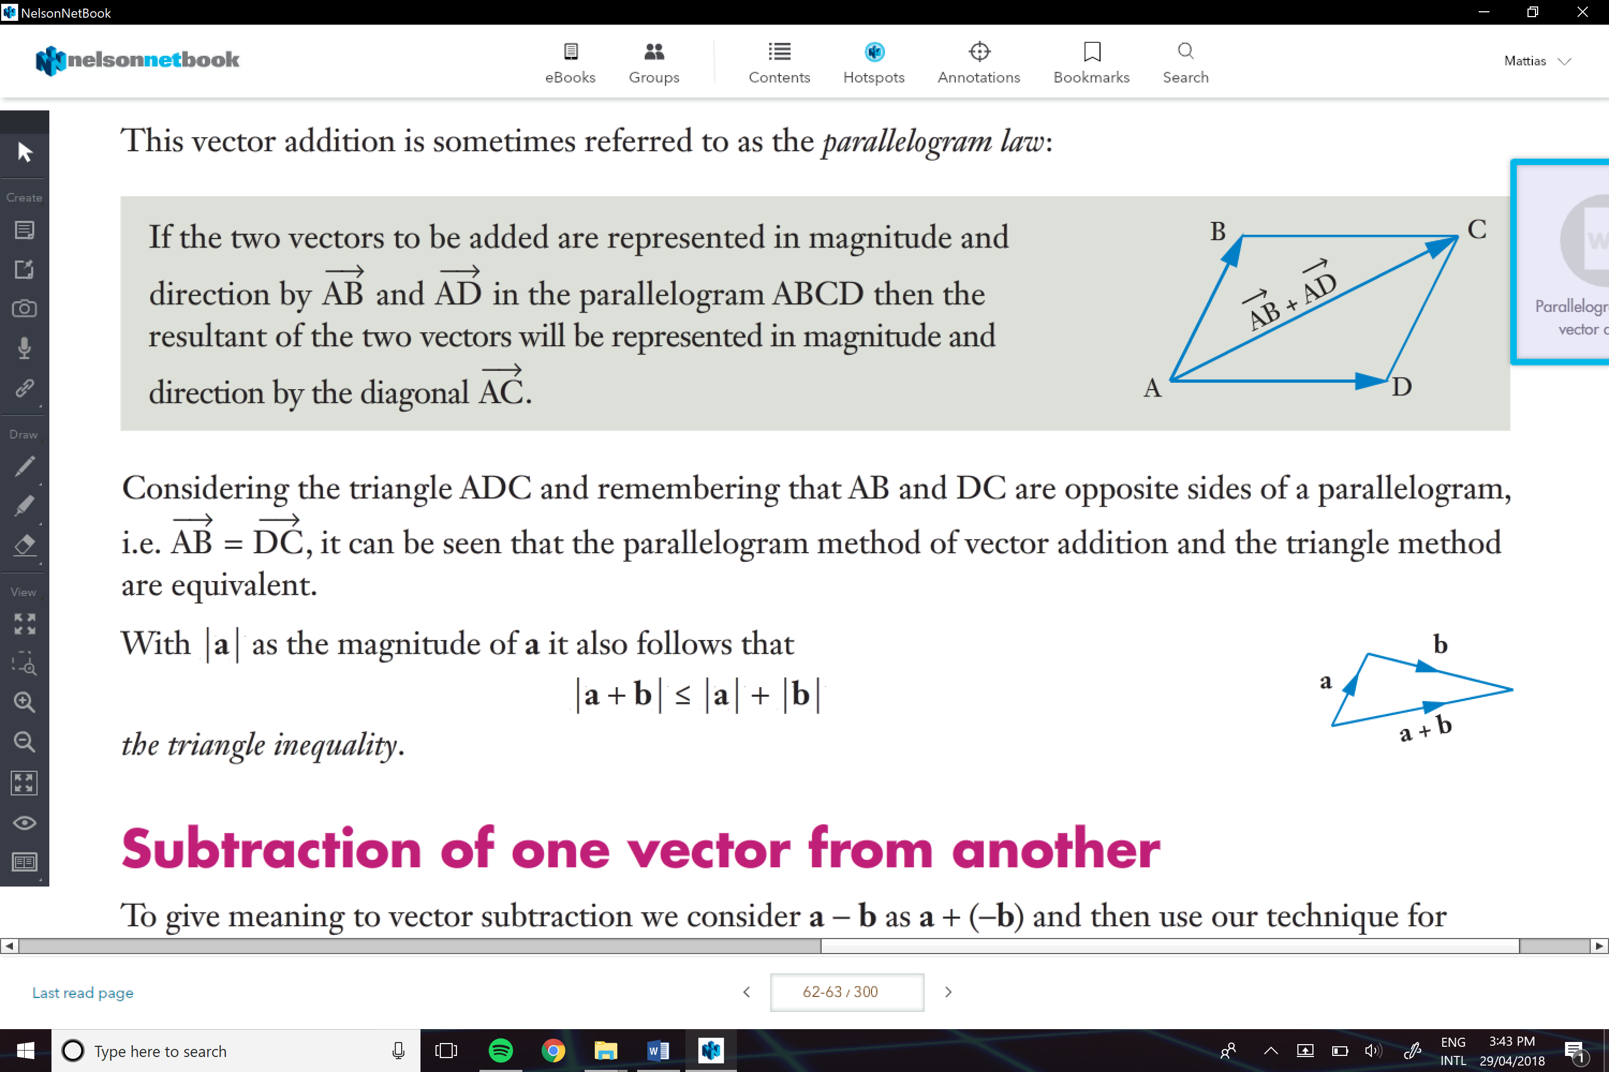

The zero Vector:

When we add a vector to the negative of its self we obtain the zero vector:

P+(-P) = 0

-The zero vector has zero magnitude and an undefined direction, we can write the zero vector as 0

ha=kb

1. a and b are parallel – because one is a scalar multiple of the other)
2. or h=k=0

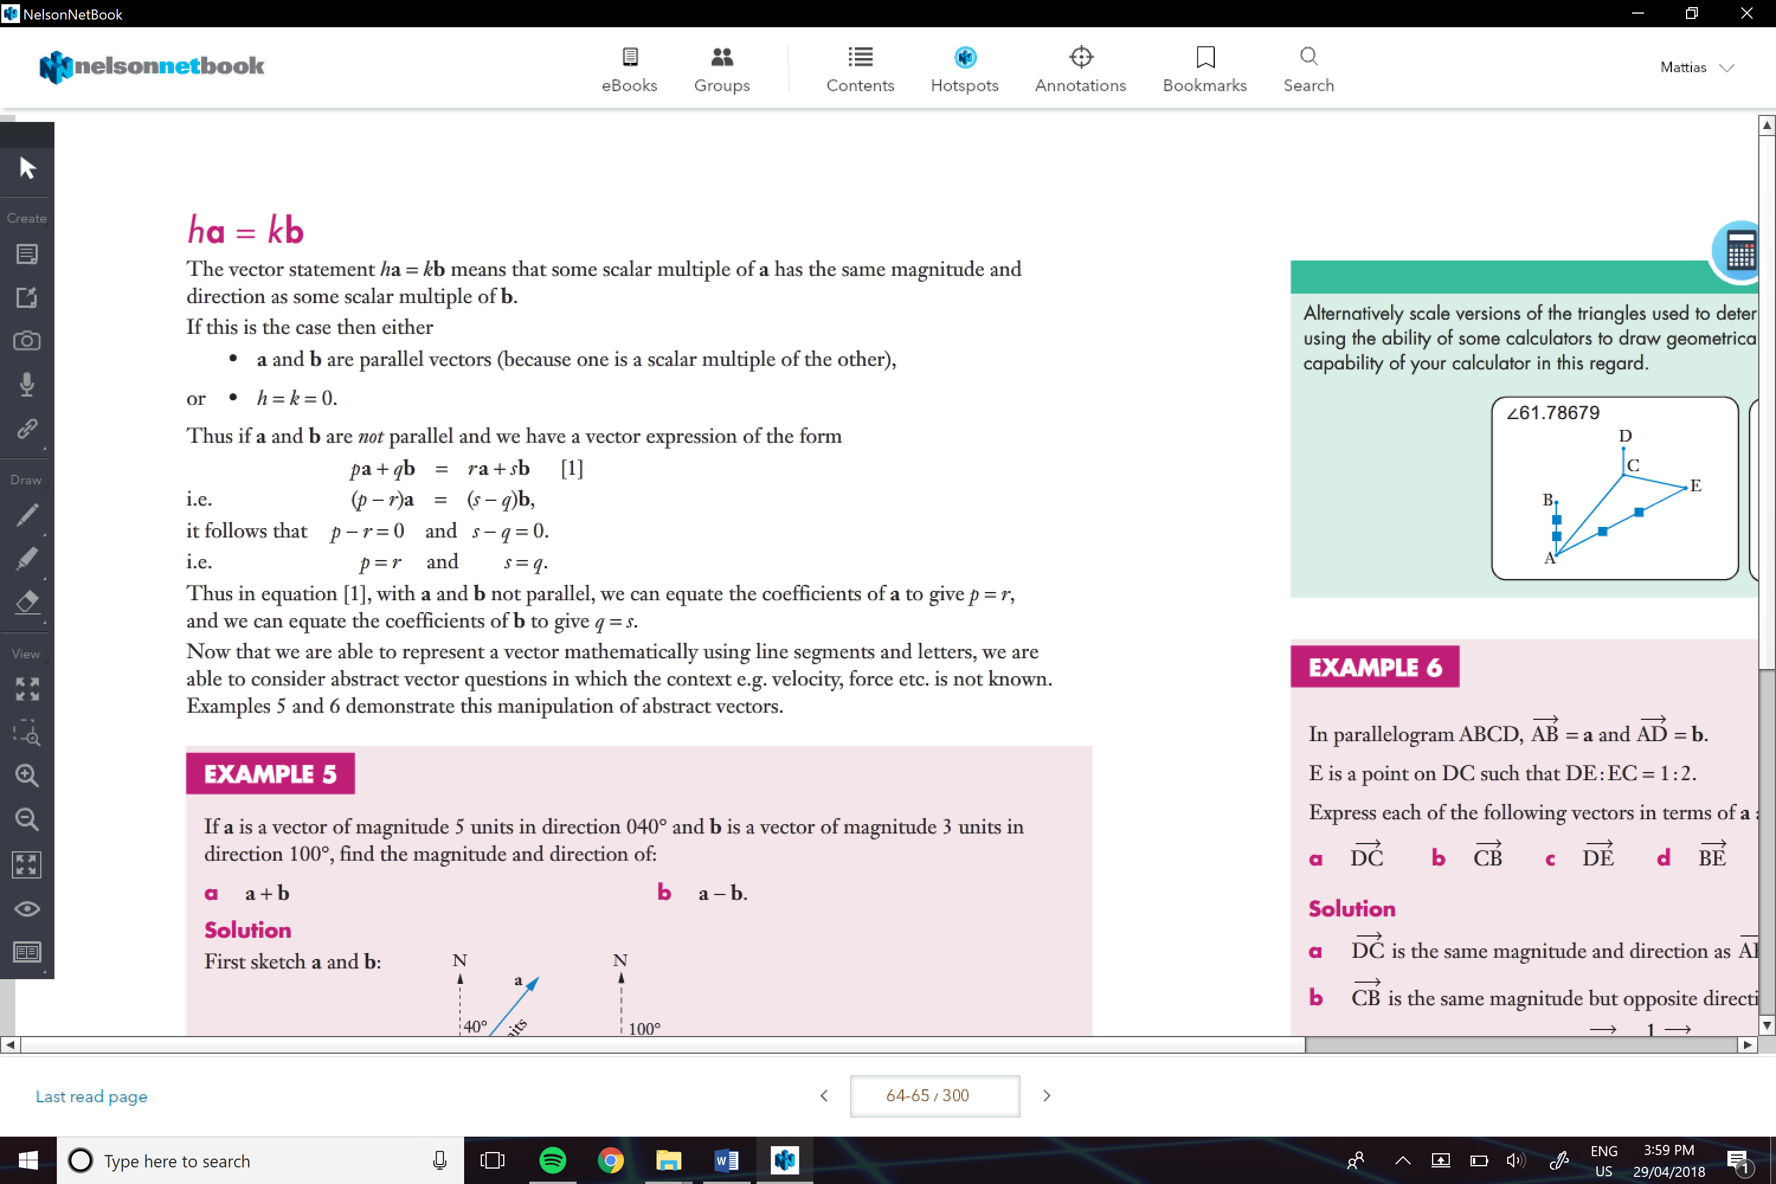

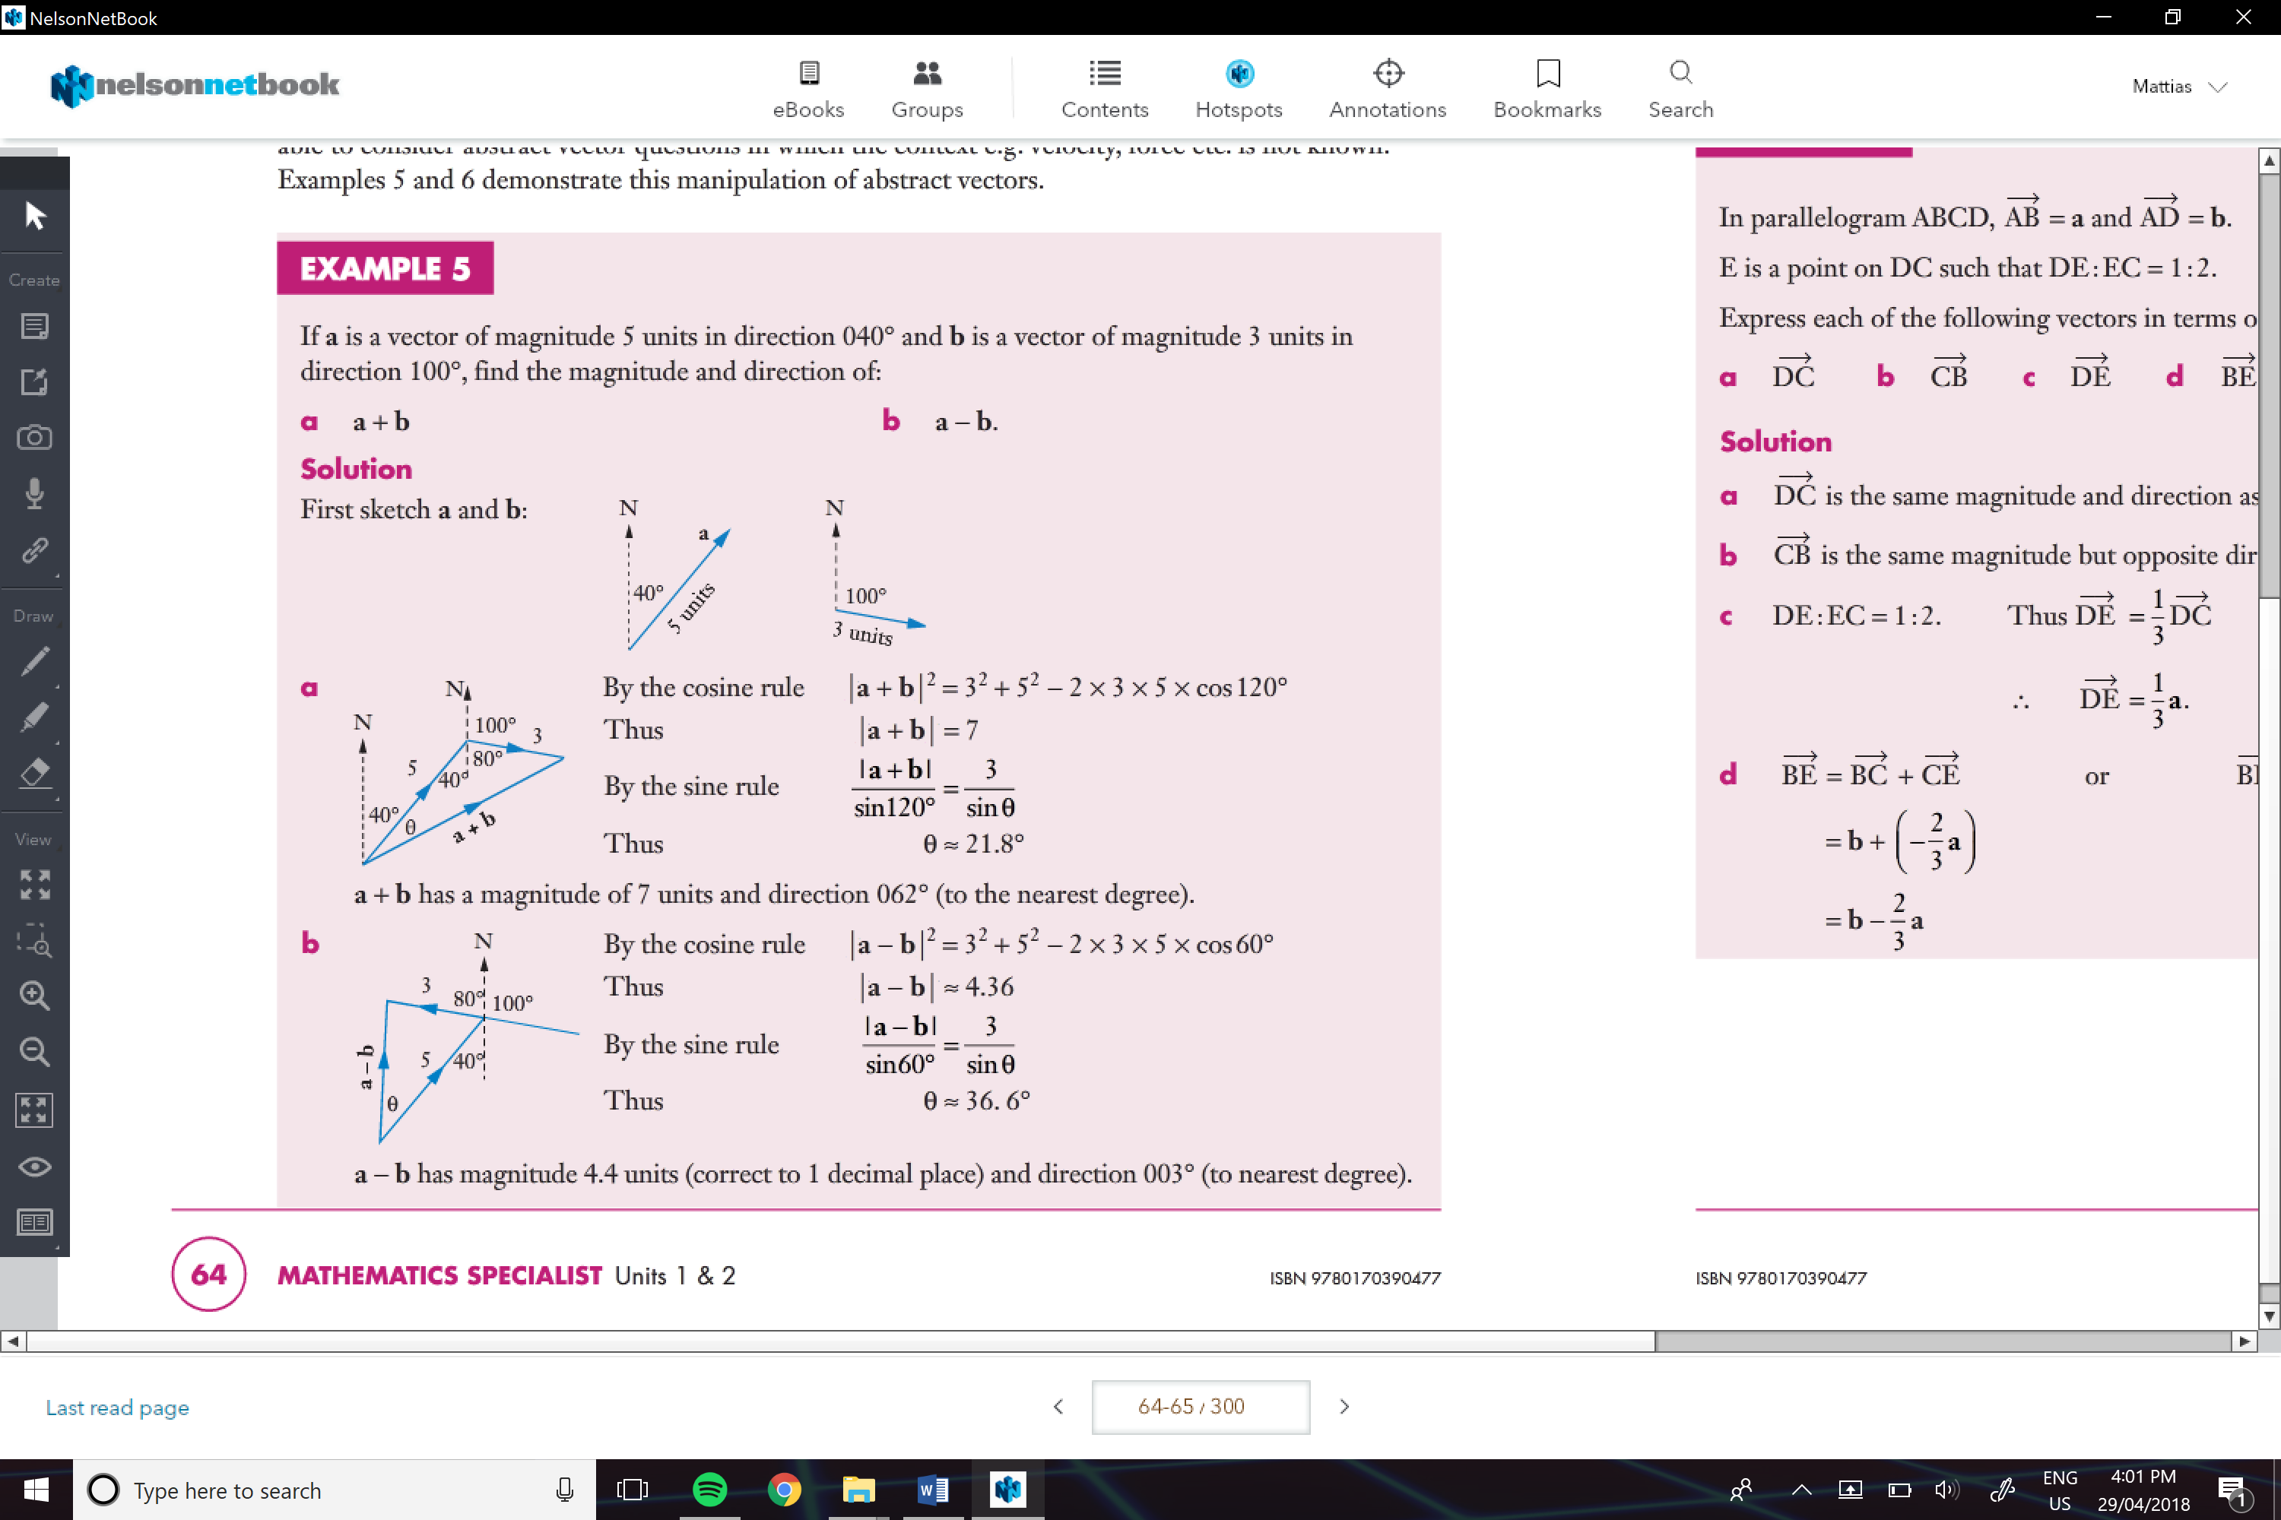

e.g. of using sides to describe other sides

